Different datasets and model architectures

We can have different types of datasets and inputs for a model. Those are some examples:

- Our dataset can be one series of numbers x of shape (seq_length) which can be for example a temperatue measurements from the past and we want to predict a temperature in the future.

In this case we can create different features which will be an input for a model and which we will use to predict the future value x[t+1].

For example those features can be the past n values (so called lags) x[t-n], ..., x[t], average or maximum value from last 7 days.

More examples are here: https://www.analyticsvidhya.com/blog/2019/12/6-powerful-feature-engineering-techniques-time-series/#h-feature-engineering-for-time-series-6-domain-specific-features

- Our dataset can consists of many different series of numbers. That is a variable x of shape (no_samples, seq_length).

It can be for example different measurements from sensors which we want to classify. In this case an input for a model will be a whole measurement of shape (seq_length)

Another example might be daily sales for different customers. If we want to predict future sales for a given customer we can use techniques from the previous point but when we are calculating those features like lags or average value from last 7 days we need to take only data for that specific customer.

- Our dataset can consists of many different series of numbers with additional static features. For example we may have daily sales for customers (time series) plus some features of those customers (what is their sector, for how long they are our clients, is this an invidual client or a company).

In this case we have two seperate inputs: one is x1 of shape (no_samples, seq_length) which is our time series variable about daily sales and another one x2 of shape (no_samples, no_features) which is a set of our static features.

X1 can be an input for one model (model_1), for example LSTM and x2 can be an input for another model (model_2), for example a fully connected neural network. Then we can take outputs from both models, model_1 and model_2, concatenate them or sum up and use this as an input for the final model which can be also a fully connected neural network:
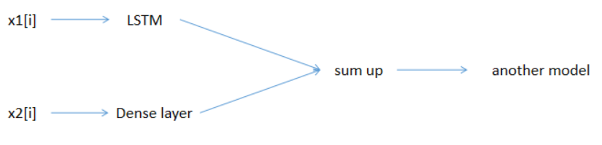

I think that instead of using multiple different models we can use the Autoformer model.

- For all above examples we can have additionally dynamic features. Those are features which are changing in time.

If x1 is our time series variable of shape (no_samples, seq_length), then our dynamic features will be a variable x2 of shape (no_samples, seq_length, no_features). x2[i][j][k] is the k-th feature for the x1[i][j] data point.

Those dynamic features can be for example time features like day of week, month, year. I think that we can use a multivariate model in order to include those dynamic features or we can pass them as input to the Embedding layer and output from that layer add to x1:
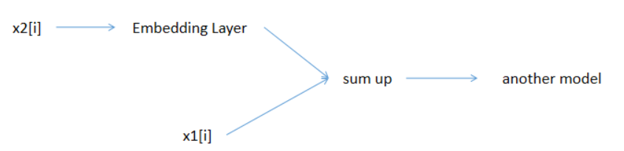

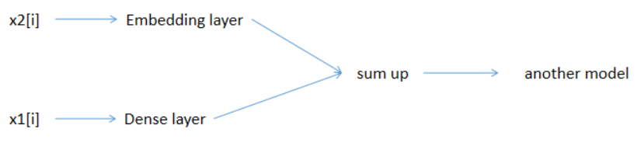

Useful website with more info about time features:
https://developer.nvidia.com/blog/three-approaches-to-encoding-time-information-as-features-for-ml-models/

- Autoformer model can take as input time series data x1 of shape (no_samples, seq_length, 1), static features variable x2 of shape (no_samples, no_features) and dynamic features x3 of shape (no_samples, seq_length, no_features)

